LB Domain:

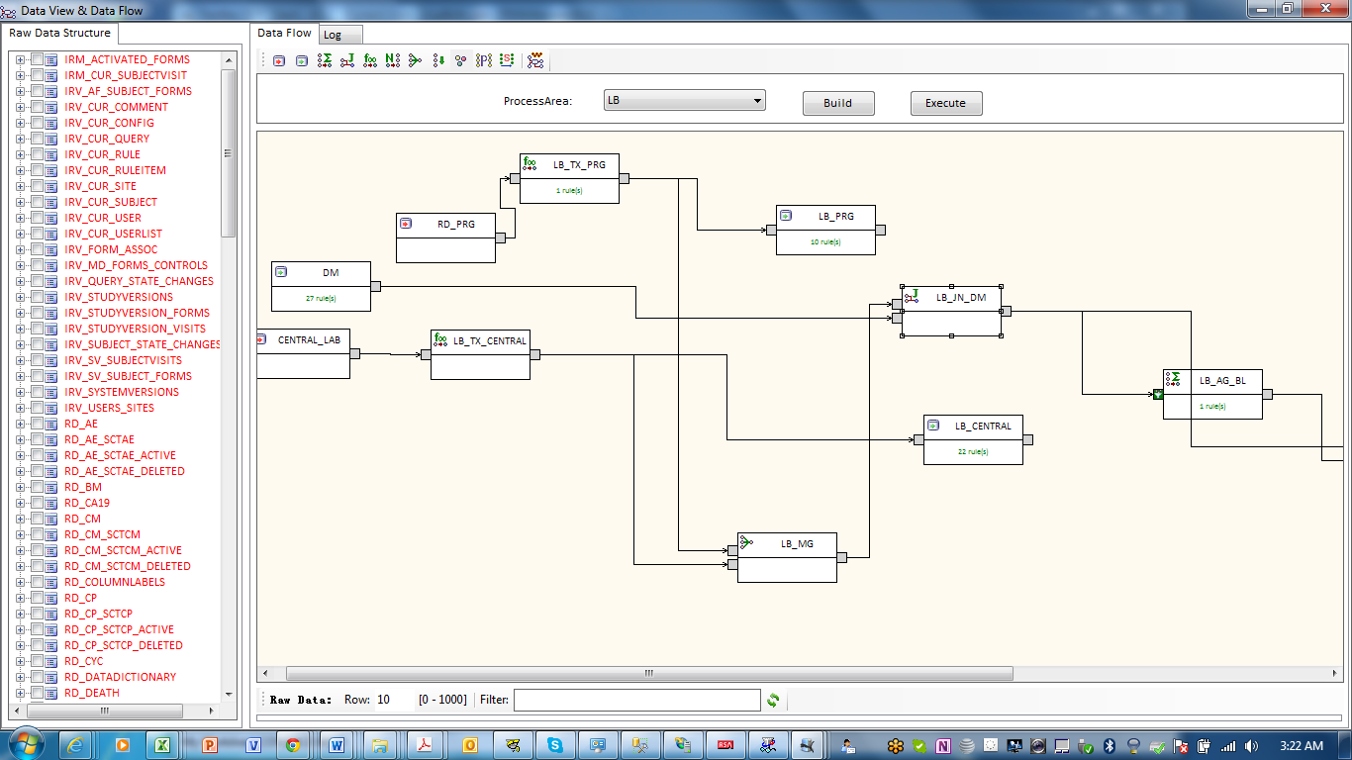

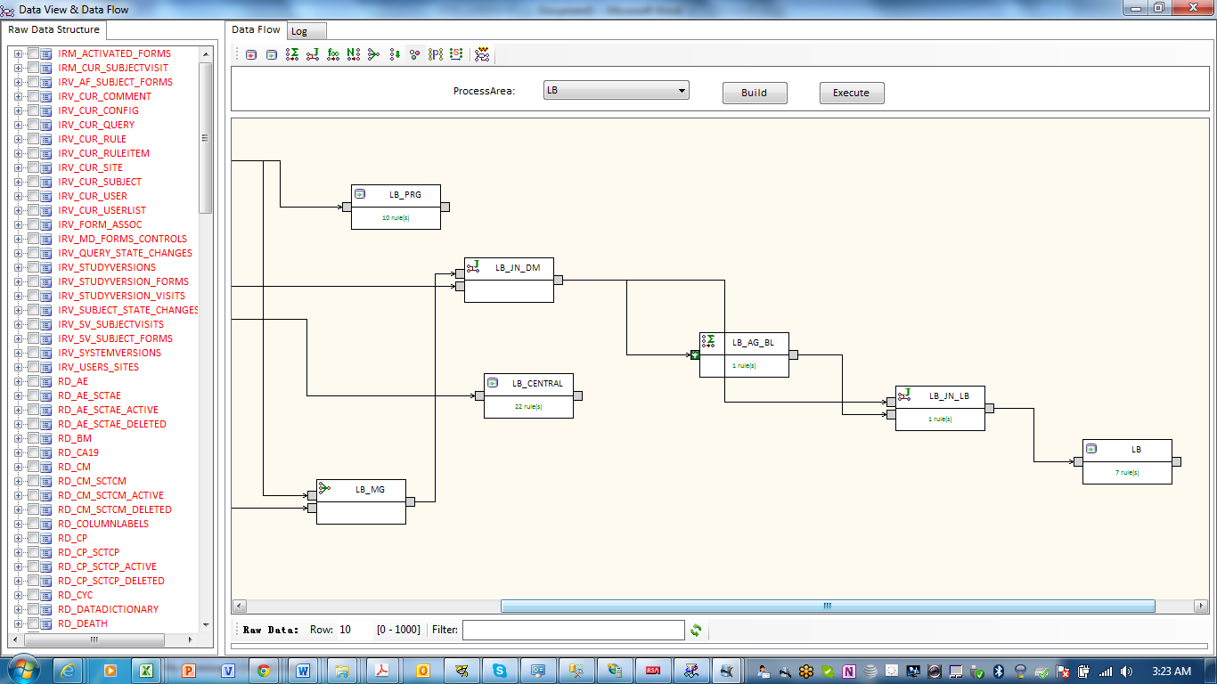

LB_JN_DM: Properties and Transformation tab are blank. Only Join Keys are defined based on USUBJID.

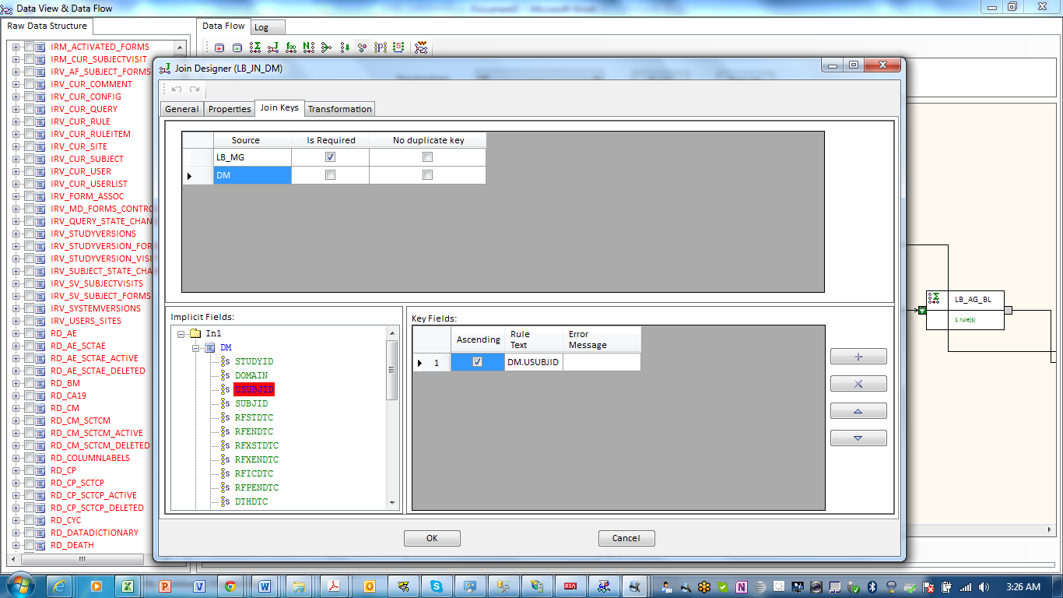

LB_AG_BL:

1. Properties tab -> Source Filter : ''<LB.LBDTC<=DM.RFXSTDTC&&LB.LBORRES !=""

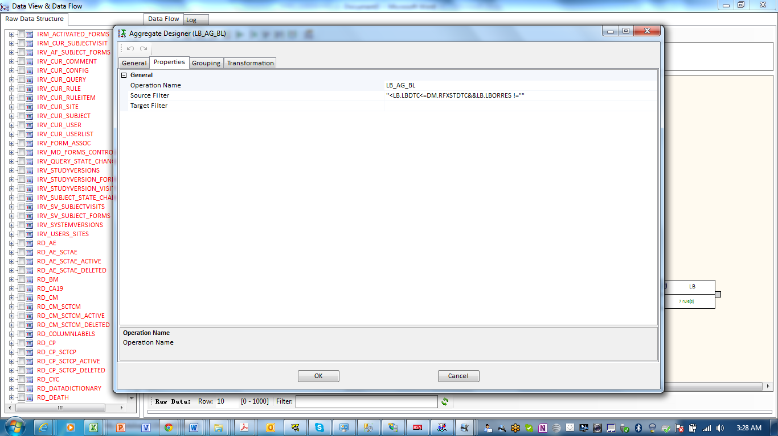

1. Grouping tab:

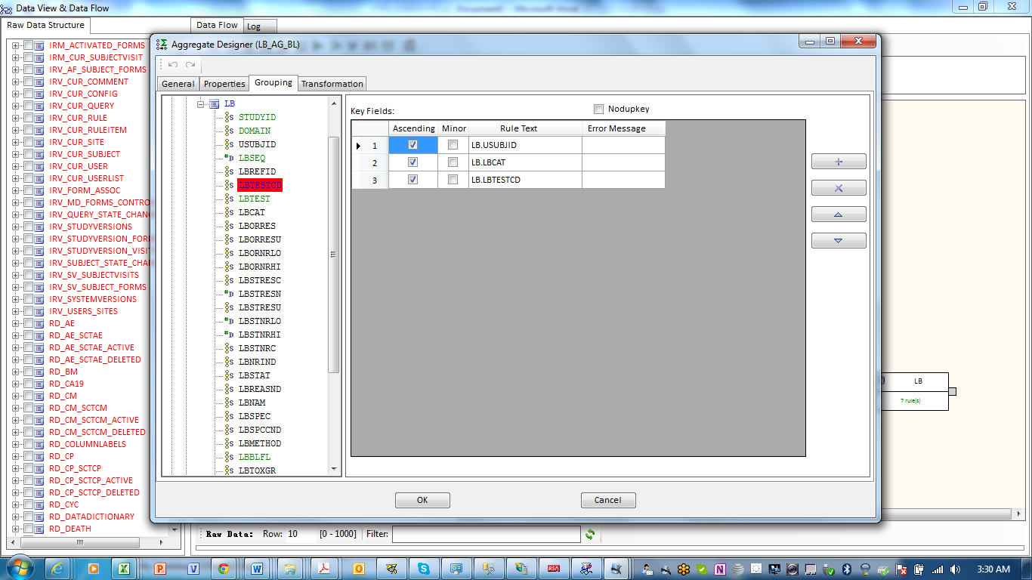

1. Transformation: smaxdate(LB.LBDTC)

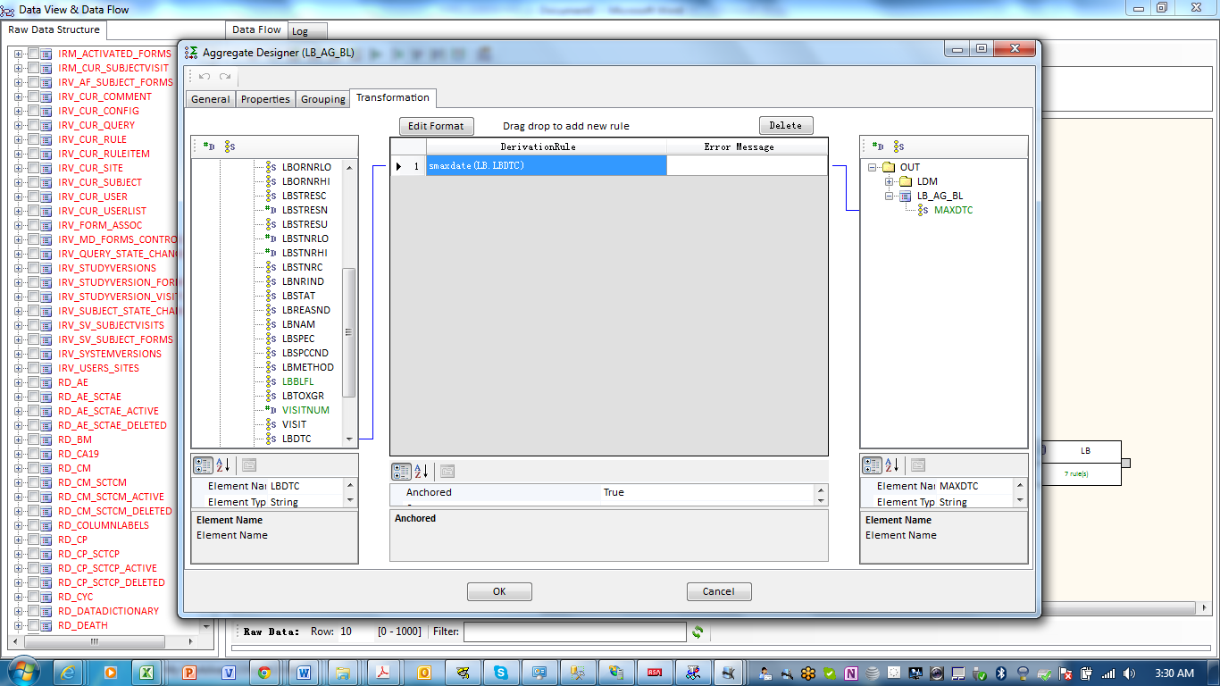

LB_JN_LB: Properties tab is null

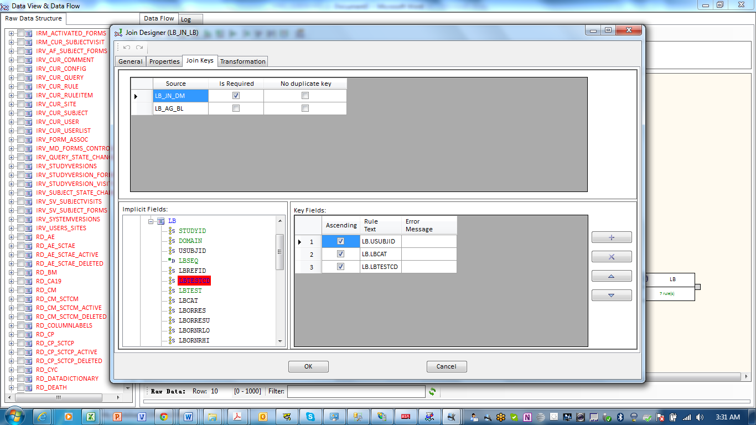

Transformation tab: LBBLFL = if(LB_AG_BL.MAXDTC == LB.LBDTC && LB.LBORRES !='')'Y'

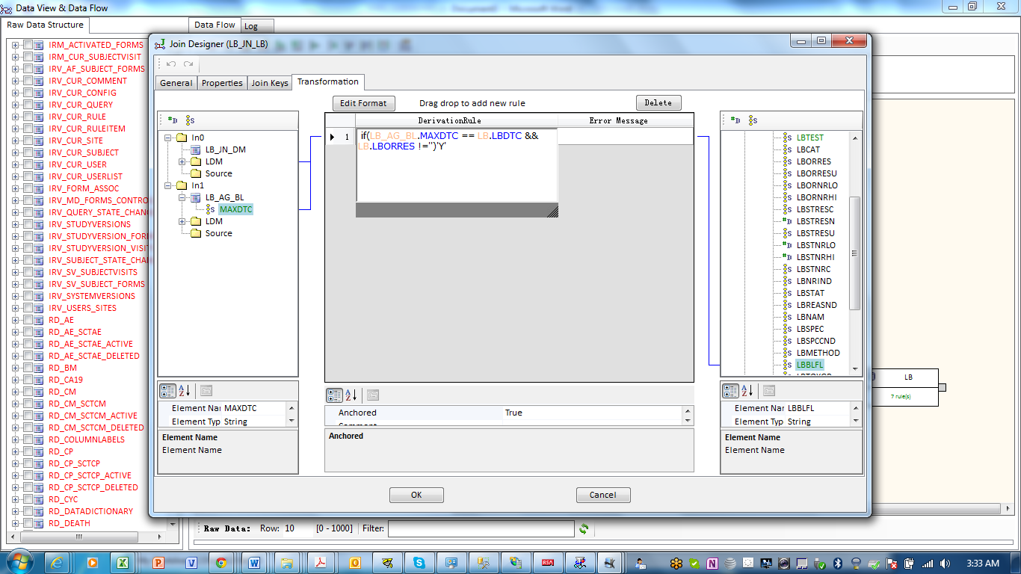

LB: LBDY=studyday(DM.RFSTDTC,LB.LBDTC)

